DECEMBER 2019 Newsletter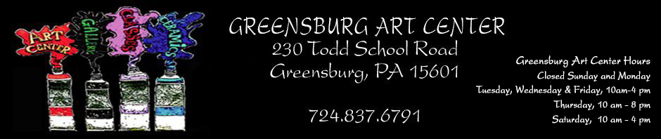December 2019 GAC Newsletter
Join Us For a Sculpture Garden Party
August 4 1-4:00 PM
See Brian McCall install an original
sculpture he created on the art center grounds.
The public is invited to enjoy free refreshments and fun at the Greensburg Art Center

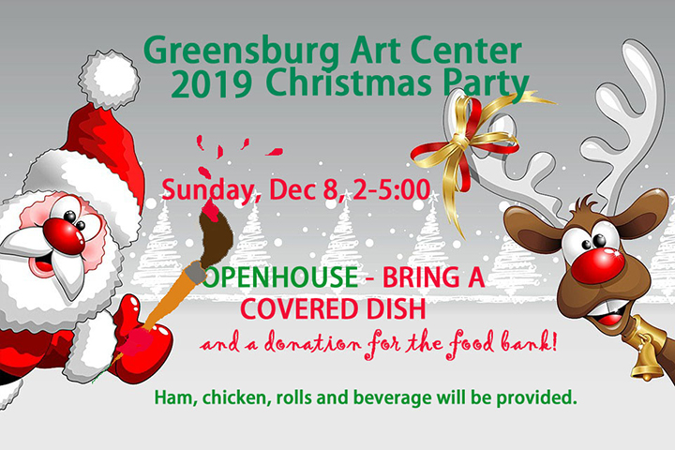
ANNUAL CHRISTMAS PARTY
GAC's Annual Christmas Party will be an OPEN HOUSE held on Sunday, Dec. 8 from 2-5pm. Attendees are kindly requested to bring a COVERED DISH or Dessert. Please RSVP to a GAC Monitor at 724-837-6791. Unanswered questions should be directed to a GAC Officer.
Call for Entries:

The Collaboration Exhibit Registration Design/Details-- The Collaboration Exhibit is designed to encourage artists to work together to create an art piece representative of their joint efforts. The aim of the exhibition is to enable artists to share ideas, points of views, and to create something that may abandon rules that guide the individual efforts. A major stipulation is that one person of the team must be a member of GAC, and that the team create a single entry (which may consist of multiple pieces). GAC members may participate in more than one team. Entry registration is due by January 15, 2020. Registration can be completed by snail mail or on-line. Prospectus is available on the website. For additional information, please contact Rose Sovyak at 412-558-0810 or Marci Koynok at 724-850-9231.
“Picture This at the Library” is a joint venture between the Greensburg Art Center and the Greensburg-Hempfield Library. The 2019 Exhibition Season ended on November 28 with Rachel Wheeler’s display of her amazing art. GAC would like to congratulate the 2019 exhibitors for their participation in this community venture that brings local artwork to the walls of the library. Kudos are extended to Tami Krusper, Mary Yeager, Dr. Janice Decker, Sarah Thomas, Kathleen Clark and Rachel Wheeler. If you are interested in becoming an exhibitor for the 2021 season, please contact Rosemary Sovyak at rosemary sovyak@gmail or 412-558-0810.
HOSPITALITY GIFT SHOP IN WESTMORELAND HOSPITAL
Kindly bring small works to Rose Sovyak who then will take them to the Westmoreland Hospital's Gift Shop. Currently, a Winter Theme in your art work is requested. Rosemarysovyak@gmail.com or 412-558-0810.
REMINDER: 2020 MEMBERSHIP DUES ARE DUE BY THE END OF DECEMBER 2019
STUDENT $25
INDIVIDUAL $40
FAMILY $70
EDUCATION
- Class Proposals for Spring classes are due Jan 31.
- Pam Cooper continues to offer Paint & Sip and birthday parties. Call 724-216-7512 to make arrangements.
- *Nina Stahlberg continues open studio Thursdays, 10-1
- *Wednesday Night Painters continue an open studio Wednesdays, 7-10
- *Jerry Scorpion invites painters to join him Saturdays, 1-4.
- Mosaics with Rose Nov 18, 1-5:00
- DARKROOM Rental - Available are several enlargers and the necessary trays, sink, safe light, timers, etc. Chemicals and developing paper are NOT included in the rental cost. Bring your negatives or film and have fun developing! Cost: $5/3 hours $25/Week INTERESTED? Contact: Shirleah Kelly 412-915-0301 or Shirleah1@aol.com

IN MEMORIUM John Edward "Jack"Sharbaugh, 1930-2019
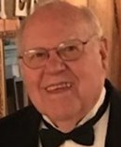
- Jack left behind Evelyn, wife of 66 years and 71 family members. He volunteered as a Treasurer and President at the Greensburg Art Center.
- While acting as President, Jack directed the construction of the Rowe Gallery.
- Condolences can be sent to Evelyn at 101 Deer Lane, Acme. 15650

Member AWARDS
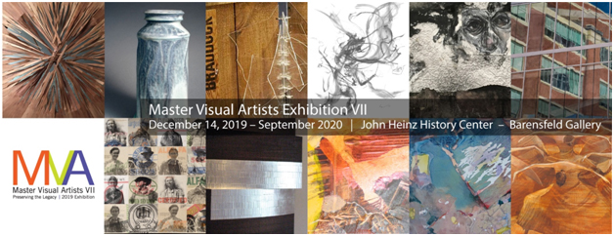
Susan E. LaansmaPollins is being Honored in"Master Visual Artist Vii: Preserving the Legacy", an exhibition shown at the Barensfeld Gallery at the Heinz History Center. Artists were chosen for lifetimeworks, achievements and contributions to the arts in Western Pennsylvania. It begins December 14 and runs through September 2020.
24th Annual Southwestern Pennsylvania Council of the Arts Prize Winners
- Emerald Effect, 3rdd Prize, Ron Nigro
- Quit While You'erA Head, Award of Excellence, Alexis Dillon
- Near Atlantic Avenue, Award of Excellence, Paula Martino
- Lineville Farmhouse Supply, Award of Merit, Pamela Beatty
- Winter's Edge, Award of Merit, Richard McWherter
INSTAGRAM
- To view GAC on Instagram, go to Instagram.com, download the free app, and type in greensburgartcenterandgallery (all one word) in the “Search” box at the top of the page. For our members who want to share their work and be shown as a member of GAC, please send photos and comments in an email to jkmoreno@msn.com. Those teaching classes or organizing other activities at GAC can do the same. Questions? Please email or call Jacki at 412 977-4323.
Opportunity for Artist Market Members Only: GAC is accepting "Small Works. For guidelines, please go to http://www.greensburgartcenter.org under Artist Market. Watch for more details in emails and Facebook.
PHASE III TO HONOR SPECIAL PEOPLE IN OUR LIVES AND … BEAUTIFY GAC GROUNDS.
You are invited to have a living testament of your love for very special people in your lives. Trees (and selected shrubs) will include ground markers” In Honor of” or “In Memorium of" for the person(s) you select. Gifts of this type will range from $75 to $275. Payments can be made by check, credit card, or PayPal. PRICES INCLUDE PLANTING AND PLAQUES.
- New donations toward this project will wait until Spring, and an additional area of landscaping will have to be considered.
CORRESPONDENCES SECRETARY’S REQUEST
During the absence of Corresponding Secretary Mary Ann Calabrase, please send information for get well, sympathy, thinking of you, etc. cards to: Barbara Park, 514 Hampton Street, Greensburg, PA 15601.
NOTE: MARY ANN CALABRASE is currently mending from an arm injury. She may be difficult to contact for a week or more. Just a thought--Maybe send her a Get-Well card. Send to 10 Claremont Drive, Greensburg, PA15601.
Donations — For all of you who love the Greensburg Art Center SHOW YOUR SUPPORT IN A MEANINGFUL WAY TO HELP US CONTINUE TO SERVE AS A TRUE COMMUNITY ART CENTER THROUGH YOUR CONTRIBUTION TO THE CENTER…Download the Special Donor Form at http://www.greensburgartcenter.org/GAC/special-donors/or to donate via PayPal. Call 724-837-6791.
MONITORS Monitors volunteer for 3-hour shifts. They are trained by experienced monitors. A packet of info on duties and procedures are given to you. A MONITOR REWARDS PROGRAM in place enables you to earn points based on the number of shifts you take. These points translate into discounts that can be applied to your tuition for classes and workshops--NOT to items in the gift shop. Points and percentages are compiled once every four months. Four shifts equal a 10% discount. Monitor more often, and your discount increases. Go to greensburgartcenter.org and click on the "welcome" printed in white letters under the paint tubes. Then click below on "Monitor Rewards Program. Questions? Please contact Alice O'Brien at alicemob@yahoo.com.
STANDING COMMITTEES IN NEED OF NEW VOLUNTEERS - If you have even a little bit of time and can help sporadically, we could use some new faces for these committees - Gallery (extra hands to install exhibits, do mailings, handle receiving and pickup, set up for openings, and refreshments), Facilities help.
CALL for TEACHER--Lithograph Teacher needed at GAC.
The Westmoreland Museum of American Art: Call for Pop-Up Exhibition Proposals. The Westmoreland is accepting proposals for Pop-Up Exhibitions, which are held in the Robertshaw Gallery (adjacent to the lobby on the 1st floor). Artists working in all media will be considered. Site-specific installations are welcome. Guidelines for submitting proposals are available at: www.thewestmoreland.org/about/opportunities/
Monitors--ATTENTION: THE BLUE GARBAGE CAN IN THE KITCHEN IS FOR RECYCLING ONLY. IT Should be put our every MONDAY for Tuesday pickup.
Newsletter Submissions to Shirleah Kelly- shirleah1@aol.com. Note-De. 28is the Final submission date for January's Newsl Lost your copy of the Newsletter. No worries! The latest version is always available on the web at www.greensburgartcenter.org.

