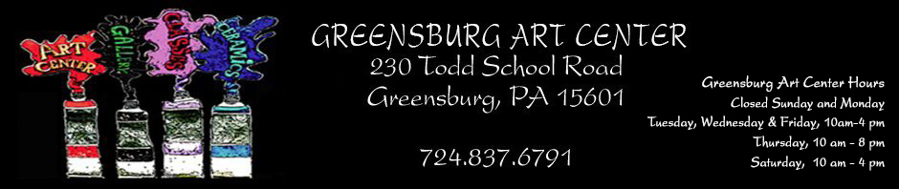
Join Us For a Sculpture Garden Party
August 4 1-4:00 PM
See Brian McCall install an original
sculpture he created on the art center grounds.
The public is invited to enjoy free refreshments and fun at the Greensburg Art Center

January 2020 Newsletter



Call for Collaboration:
- The Collaboration Exhibit Registration Design/Details-- The Collaboration Exhibit is designed to encourage artists to work together to create an art piece representative of their joint efforts. The aim of the exhibition is to enable artists to share ideas, points of views, and to create something that may abandon rules that guide the individual efforts. A major stipulation is that one person of the team must be a member of GAC, and that the team create a single entry (which may consist of multiple pieces). GAC members may participate in more than one team. Entry registration is due by January 15, 2020. Registration can be completed by snail mail or on-line. Prospectus is available on the website. For additional information, please contact Rose Sovyak at 412-558-0810 or Marci Koynok at 724-850-9231.
Good wishes to Bonnie and Bill Hoffman as they move to the other side of the state.

SAVE THE DATE-- ART ON THE VINE Saturday, April 18, 2020, 6-9:00 PM
Let's meet Henri de Toulouse Lautrec at the Moulin Rouge!

“Picture This at the Library” is a joint venture between the Greensburg Art Center and the Greensburg-Hempfield Library. The 2019 Exhibition Season ended on November 28 with Rachel Wheeler’s display of her amazing art. GAC would like to congratulate the 2019 exhibitors for their participation in this community venture that brings local artwork to the walls of the library. Kudos are extended to Tami Krusper, Mary Yeager, Dr. Janice Decker, Sarah Thomas, Kathleen Clark and Rachel Wheeler. If you are interested in becoming an exhibitor for the 2021 season, please contact Rosemary Sovyak at rosemary sovyak@gmail or 412-558-0810.
HOSPITALITY GIFT SHOP IN WESTMORELAND HOSPITAL
Kindly bring small works to Rose Sovyak who then will take them to the Westmoreland Hospital's Gift Shop. Currently, a Winter Theme in your art work is requested. Rosemarysovyak@gmail.com or 412-558-0810.
REMINDER
2020 MEMBERSHIP DUES were DUE BY THE END Of 2019
STUDENT $25
INDIVIDUAL $40
FAMILY $70

- Education:
- Class Proposals for Spring classes are due Jan 31. Classes begin in March.

- DARKROOM Rental - Available are several enlargers and the necessary trays, sink, safe light, timers, etc. Chemicals and developing paper are NOT included in the rental cost. Bring your negatives or film and have fun developing! Cost: $5/3 hours $25/Week INTERESTED? Contact: Shirleah Kelly 412-915-0301 or Shirleah1@aol.com

- MEMBER’S NEWS
- 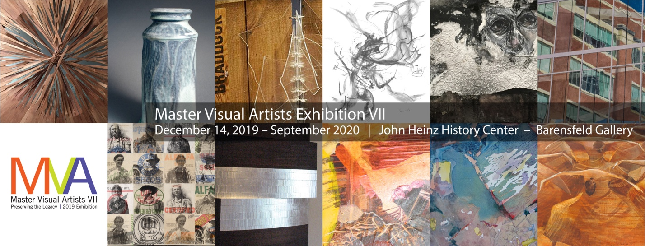
- Susan E. Laansma Pollins is being Honored in"Master Visual Artist Vii: Preserving the Legacy", an exhibition shown at the Barensfeld Gallery at the Heinz History Center. Artists were chosen for lifetimeworks, achievements and contributions to the arts in Western Pennsylvania. It begins December 14 and runs through September 2020.We are encouraging all to attend the Opening Reception on January 9 at 5:30pm.

- INSTAGRAM .To view GAC on Instagram, go to Instagram.com, download the free app, and type in greensburgartcenterandgallery (all one word) in the “Search” box at the top of the page. For our members who want to share their work and be shown as a member of GAC, please send photos and comments in an email to jkmoreno@msn.com. Those teaching classes or organizing other activities at GAC can do the same. Questions? Please email or call Jacki at 412 977-4323.
****************************************************
Thank you to our “2019 END-OF-YEAR DONORS”
Here they are listed by giving level:

PLATINUM DONORS ($501+)
Bob and Arlene Kendra Susan Kiren Bob and Pat Majcher
Kay Rowe Ken and Sue White

GOLD DONORS ( $251-500)
Dr. Gerard and June Penta Rose and Fred Sovyak

SILVER DONORS ($101-250)
Phyllis Bertok Cathy Genard Riser William and Bonnie Hoffman
Shirleah and Keith Kelly Adam and Kristin Majcher Betty Reese Sharyn Sekora

BRONZE DONORS ($50-100)
Marlene Barbe Ward Berg Jr. Harry and Gayle Blansett
Peg Carpenter Carl Castille Glenn and Jacquelyn Cavanaugh
Ken and Lynn Cutway William DeBernardi John and Natalie Debich
Nina and Ray Defazio Gilbert Devine Suzanne Evancho
Carolyn Falcon Patricia Gatons Al and Carol Kave
Maura Koehleer Keeney Ron and Judy Korczynski Frances Lynch
Donna Merritts Anita Mesich Grace and Dan Miller
Claudia Miller Mary Ann Mogus Mary Jane Morelli
Mrs. Barbara H. Nakles Peg Panasiti Calvin and Mary Frances Pollins
Sue Pollins John Sinosky Jeanne and Del Smith
Marquis Smith, Jr. Jess Stairs Stuart and Nora Thompson
Lois Ann Watson Mary Ann and Jeff Wolfe

DONORS ($1-49)
Mary Aleo Betty Hammer Amy Mongell Judy Smith Don Waxter

Opportunity for Artist Market Members Only:GAC is accepting "Small Works.For guidelines, please go to http://www.greensburgartcenter.orgunder Artist Market. Watch for more detailsin emails and Facebook.

PHASE III TO HONOR SPECIAL PEOPLE IN OUR LIVES AND … BEAUTIFY GAC GROUNDS.

You are invited to have a living testament of your love for very special people in your lives. Trees (and selected shrubs) will include ground markers” In Honor of” or “In Memorium of" for the person(s) you select. Gifts of this type will range from $75 to $275. Payments can be made by check, credit card, or PayPal. PRICES INCLUDE PLANTING AND PLAQUES.
New donations toward this project will wait until Spring, and an additional area of landscaping will have to be considered.

CORRESPONDENCES SECRETARY’S REQUEST
During the absence of Corresponding Secretary Mary Ann Calabrase, please send information for get well, sympathy, thinking of you, etc. cards to: Barbara Park, 514 Hampton Street, Greensburg, PA 15601.
NOTE: MARY ANN CALABRASE is currently mending from an arm injury. She may be difficult to contact for a week or more. Just a thought--Maybe send her a Get-Well card. Send to 10 Claremont Drive, Greensburg, PA15601.

Future Donations —For all of you who love the Greensburg Art Center SHOW YOUR SUPPORT IN A MEANINGFUL WAY TO HELP US CONTINUE TO SERVE AS A TRUE COMMUNITY ART CENTER THROUGH YOUR CONTRIBUTION TO THE CENTER…Download the Special Donor Form at http://www.greensburgartcenter.org/GAC/special-donors/or to donate via PayPal. Call 724-837-6791.
MONITORS Monitors volunteer for 3-hour shifts. They are trained by experienced monitors. A packet of info on duties and procedures are given to you. A MONITOR REWARDS PROGRAM in place enables you to earn points based on the number of shifts you take. These points translate into discountsthat can be applied to yourtuition for classes and workshops--NOT to items in the gift shop. Points and percentages are compiled once every four months. Four shifts equal a 10% discount. Monitor more often, and your discount increases. Go to greensburgartcenter.org and click on the "welcome" printed in white letters under the paint tubes. Then click below on "Monitor Rewards Program. Questions? Please contact Alice O'Brien at alicemob@yahoo.com.
STANDING COMMITTEES IN NEED OF NEW VOLUNTEERS - If you have even a little bit of time and can help sporadically, we could use some new faces for these committees - Gallery (extra hands to install exhibits, do mailings, handle receiving and pickup, set up for openings, and refreshments), Facilities help.
CALL for TEACHER--Lithograph Teacher needed at GAC.
 The Westmoreland Museum of American Art: Call for Pop-Up Exhibition Proposals. The Westmoreland is accepting proposals for Pop-Up Exhibitions, which are held in the Robertshaw Gallery (adjacent to the lobby on the 1st floor). Artists working in all media will be considered. Site-specific installations are welcome. Guidelines for submitting proposals are available at: www.thewestmoreland.org/about/opportunities/
Monitors--ATTENTION: THE BLUE GARBAGE CAN IN THE KITCHEN IS FOR RECYCLING ONLY. IT Should be put our every MONDAY for Tuesday pickup.

Newsletter Submissions to Shirleah Kelly- shirleah1@aol.com. Note-January 29 is the Final submission date for February's Newsl
Lost your copy of the Newsletter. No worries! The latest version is always available on the web at www.greensburgartcenter.org.

